- Determine the equation of the line tangent to the curve at .
- Determine all values of x where has tangent lines parallel to the line .
- Determine the equation of the line tangent to the curve at .
- Determine all values of x where has tangent lines perpendicular to the line .

- Find conditions on a, b, c, & d so that the graph of the polynomial has…
- exactly two horizontal tangents.
- exactly one horizontal tangent.
- no horizontal tangents.

- Find k if the curve is tangent to the line .

- Find all values of a such that the curves and intersect at right angles.

- The segment of any tangent line to the graph of that is cut off by the coordinate axes is bisected by the point of tangency.

- Show this works for when .
- Show this works for when .

- Suppose that the function f is differentiable everywhere and that .
- Express a formula for in terms of x and derivatives of f.
- Express a formula for in terms of x and derivatives of f.
- For, conjecture of formula for .

- Consider the polynomial functions , , and , where represent real numbers.
- Find , , and .
- If n represents the degree of the polynomial, then what is the -st derivative of any polynomial? Why?
- Newton’s Law of Universal Gravitation states that the magnitude F of the force exerted by a point with mass M on a point with mass m is where G is a constant and r is the distance between the bodies. Assuming that the points are moving, find a formula for the instantaneous rate of change of F with respect to r.

- Show that if exists for each x in , then is continuous on .

- The following graph depicts the position of two racers.
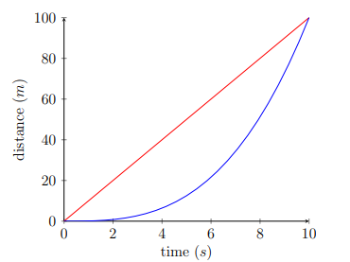
- Which racer has a faster average speed? When was each racer running faster than the other (approximately)? Which racer was running fastest at the end of the race?
- On a separate plot from this picture, sketch the graphs of the velocities of these racers.
- Suppose that the distance (from the starting point) of the red racer is given by the function and the distance of the blue racer is given by . Suppose that & . Use this new information (and your knowledge of derivatives) to check whether your answers in parts (a) and (b) were accurate.

